EFFECTS OF COMPRESSIVE STRESS ON PORE VOLUME OF NONWOVENS

Akshaya Jena and Krishna Gupta
Porous Materials, Inc.
Ithaca, New York

ABSTRACT

A novel technique capable of measuring pore volume and pore volume distribution as a function of imposed compressive stress on the sample is considered in detail. Test results have been discussed to illustrate the application of the technique.

INTRODUCTION

Nonwovens are subjected to compressive stress during service in many applications in a broad variety of industries including biotechnology, household, healthcare, filtration, paper, and power sources. The performance of nonwovens in such applications is determined by the pore structure of the nonwovens under application environments. Therefore, determination of pore volume, pore size, and pore volume distribution of nonwovens under compressive stress is relevant. None of the currently available pore structure characterization instruments is capable of measuring such pore structure characteristics as a function of compressive stress. In this paper, an innovative technology developed to measure pore volume of nonwovens as a function of desired compressive stress is discussed.

BASIC PRINCIPLES

Displacement of Wetting Liquid from a Pore
A liquid that can spontaneously flow in to pores of a sample is known as the wetting liquid. The process is spontaneous because the solid/wetting liquid interfacial free energy is less than the solid/gas interfacial free energy and filling of the pores of the sample with the wetting liquid reduces the free energy of the system. The reverse process is not spontaneous because removal of the wetting liquid from the pore by a gas replaces solid/liquid interface by solid/gas interface and increases the free energy. For displacement of the wetting liquid from a pore by the gas, the work done by the gas must be equal to the increase in the interfacial free energy. Differential pressure, p, is related to the pore diameter, D.
p = (dS_{s/g} /dV) γ_{l/g} cos θ (1)
where γ_{l/g} is gas/liquid interfacial free energy, θ is contact angle, dV is infinitesimal increase in the volume of the gas in the pore, and dS_{s/g} is infinitesimal increase of the solid/gas interfacial area. The diameter of a pore at any cross-section perpendicular to the direction of gas flow is defined as the diameter of a cylindrical opening such that:
[dS/dV] (pore) = [dS/dV] (cylindrical opening of diameter, D)
= [4 / D] (2)
Consequently [1,2,3]:
p = [4 γ_{l/g} cos θ] / D (3)
Test Method
The sample is placed on a membrane whose largest pore is smaller than the smallest pore of interest in the sample. The pores of the sample and the membrane are filled with a wetting liquid. When pressurized gas displaces liquid from the pores of the sample the displaced liquid flows out through the liquid filled pores of the membrane. Gas pressure adequate to displace the wetting liquid from the pores of interest in the sample is inadequate to displace the wetting liquid from the small pores of the membrane. During the test the pores of the membrane remain filled with liquid and prevent passage of gas to the sample chamber below the membrane (Figure 1). The volume of liquid flowing out of the membrane is the volume of pores. Differential pressure yields pore diameter.
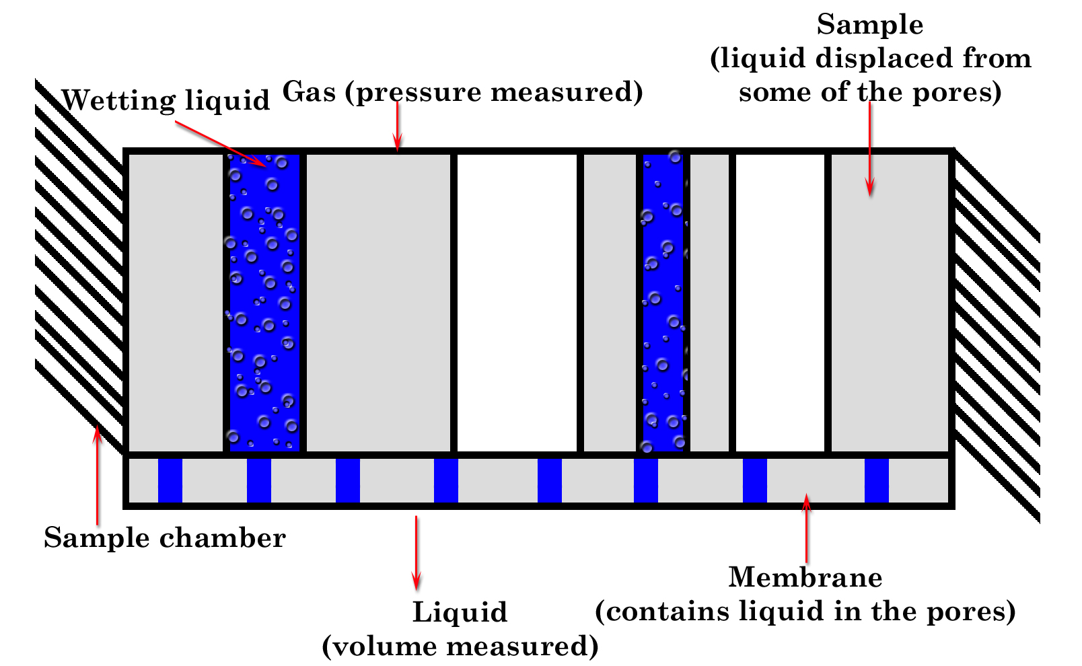

Figure 1. The liquid extrusion method

TECHNIQUE

Measurement of Displaced Liquid and Pressure
The set up is shown in Figure 2. The sample chamber below the membrane is connected to a cup supported on a weighing balance. The sample chamber below the membrane, the cup, and the tube connecting the sample chamber too the cup are filled with wetting liquid without leaving any air gap (Figure 2). The wetting liquid displaced from the pores of the sample and flowing out of the pores of the membrane flows to the cup to be measured by the balance. The differential gas pressure of test gas is measured by pressure transducers.

Compressive Stress on Sample
A smaller inner piston rod enters the sample chamber through an outer hollow piston rod. Pressure on the inner piston rod is computer controlled using the pneumatic piston-cylinder device. The sample is placed between two highly porous rigid discs and the inner piston rod compresses the sample by applying pressure on the discs. The inner piston rod is also hollow. It allows the test gas to enter the sample chamber. Openings at the bottom of the piston rod permit the gas to distribute itself. Net compressive stress on the sample is computed by subtracting the upward force due to test pressure from the downward force applied by the inner piston rod.

Sealing of Sample Chamber
The outer piston rod compresses an insert, which applies uniform controlled pressure on the o-ring at the bottom of the sample chamber to seal the membrane and prevent gas leak around the membrane (Figure 2). The o-ring between the piston rod and the insert seals the sample chamber. Pressure on the outer piston rod is computer controlled using the pneumatic piston-cylinder device. However, pressure controls on the inner and outer piston rods are completely independent of each other.
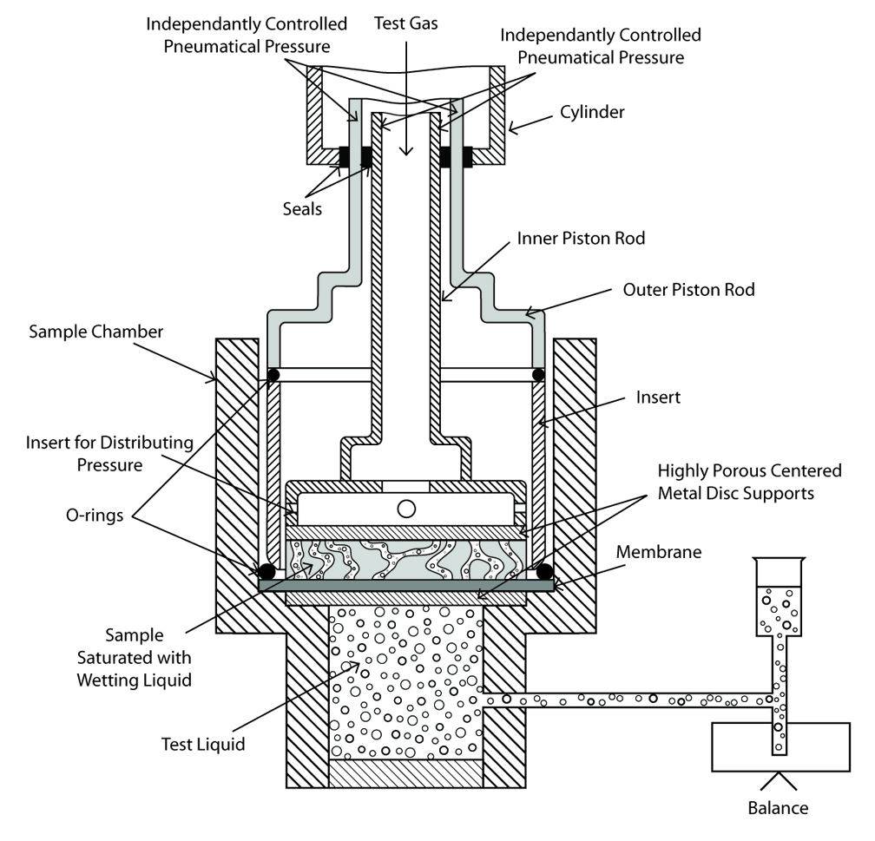

RESULTS AND DISCUSSION

.

Figure 2. The set up

Test Procedure
The cup on the balance is filled with the wetting liquid until the liquid level is just above the membrane in the sample chamber. The sample with its pores filled with the wetting liquid is placed on the membrane. Inner piston is brought down on the sample and the desired stress is applied. The outer piston is brought down to seal the sample and the chamber. The test gas is introduced. Gas pressure and weight of liquid on the balance are recorded as a function of increasing pressure. Once the test is done, the test gas pressure is reduced to zero, sample is rewetted in the sample chamber, compressive stress on the sample is increased, and the test is again executed.

RESULTS AND DISCUSSION

Through Pore Volume
The measured volume of extruded liquid is the through pore volume. Cumulative through pore volume measured as a function of pore diameter of sample without any compressive stress is presented in Figure 3. As the pressure is increased, liquid is extruded from smaller pores and the cumulative pore volume increases. When liquid from all the pores have been removed, increase of pressure does not extrude any more liquid and cumulative pore volume does not increase.

Through Pore Distribution
Distribution of pore volume over pore diameter is given by the distribution function f_{v}.
f_{v} = – [d V / d log D] (5)
where V is the cumulative pore volume. Integration of this function shows that;
∫ d V = – ∫ f_{v} d log D (6)
Thus, volume of pores in any pore diameter range is obtained from the area under the plot of f_{v} against log D. The typical variation distribution function is shown in Figure 4.

Through Pore Diameters
As the pressure is increased on the sample, liquid is first displaced from the mouth of a pore
and then from the narrower parts until the pore throat. All diameters of a pore from its mouth to its throat are measured. The pressure required to displace liquid from the throat completely displaces liquid from the pore beyond the throat without further increase in pressure. Therefore, diameters of a pore from the throat to the exit are not measured (Figure 5).

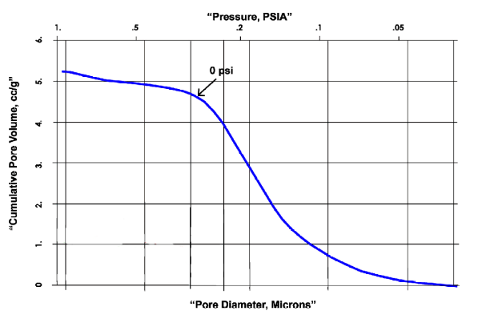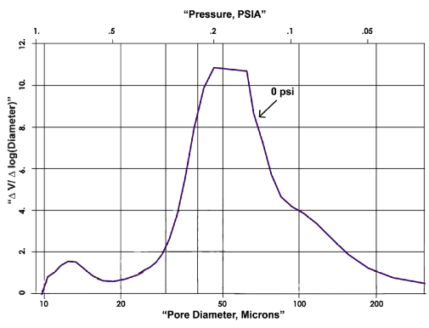
Figure 3 Cumulative pore volume Figure 4 Pore distribution

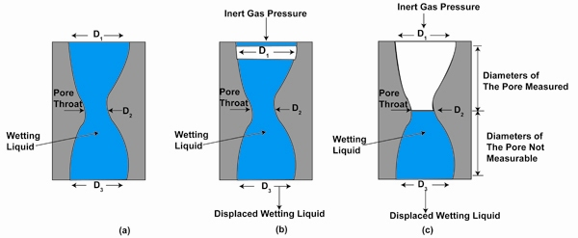

Figure 5. Measurable diameters of a through pore by liquid extrusion technique

Effect of Compressive Stress on Pore Volume
Appreciable influence of three different levels of compressive stress, 210, 420, and 590 psi on pore volume is demonstrated in Figure 6. The data in Table 1 shows that influence of compressive stress on pore volume is large in the beginning and decreases with increasing stress. The empty spaces between the fibers are eliminated in the beginning. As the fibers get squeezed, it becomes more difficult to remove pores.

Table 1 Effect of compressive stress on sample on the pore volume

Stress, psi Pore Volume, cc/g Relative Value
_________________________________________________________________________
0 5.3153 100 %
210 1.2812 24.1 %
420 1.0859 20.4 %
590 0.1874 3.5 %
__________________________________________________________________________

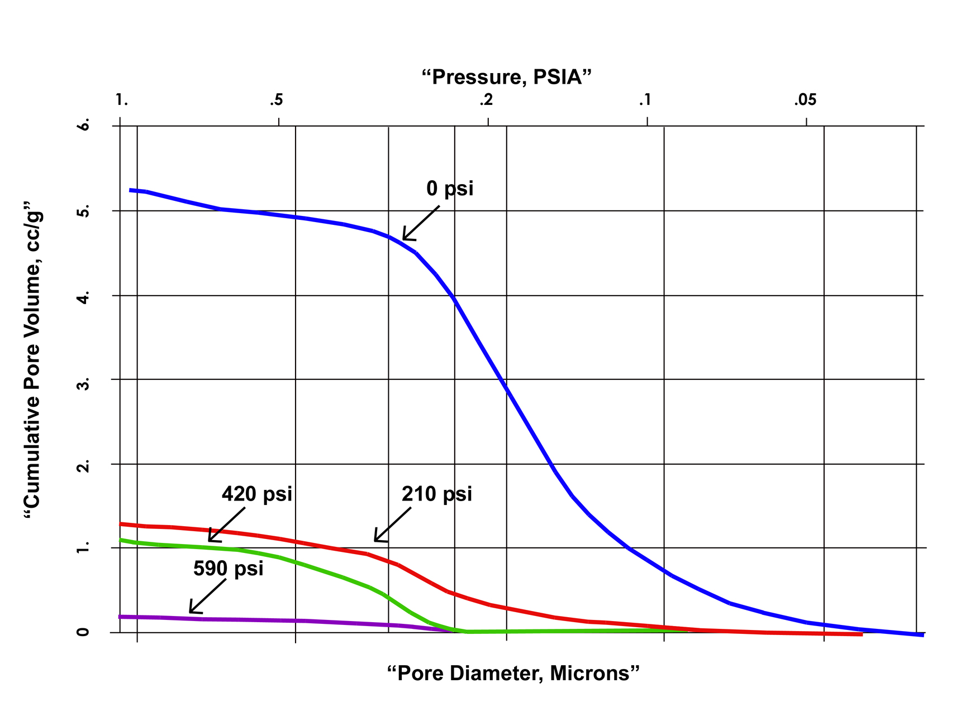
It can be shown that change in pore volume is proportional to square of stress [4]. It is clear from Figure 7 that after the initial elimination of voids, the change in pore volume increases linearly with square of stress.

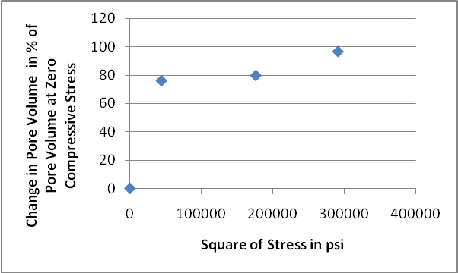

Figure 6. Effect of compressive stress Figure 7. Change in pore volume with square
on pore volume of the stress

Effect of Compressive Stress on Pore Volume Distribution
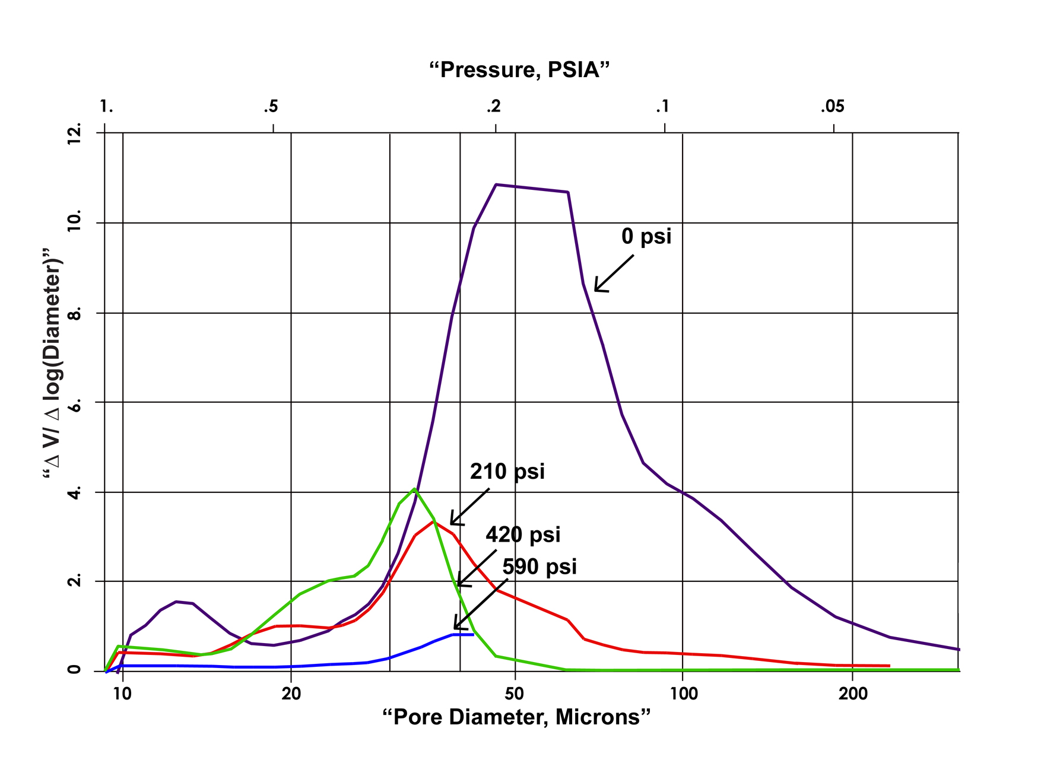
The influence of compressive stress on pore volume distribution is shown in Figure 8. The area under each curve is the total pore volume. With increasing compressive stress, the total pore volume decreases, the pore diameters become smaller, and very small pores become undetectable because of their reduced volume. The effect is appreciable in the beginning and decreases with increase in compressive stress.

Figure 8. Decreasing influence of compressive stress on pore volume
Additional Capability
The technique is versatile. In this study, the effects of compressive stress on pore volume were measured at room temperature. However, using the same equipment the effects of compressive stress on pore structure can be measured at elevated temperatures up to 200°C using many chemicals, and under controlled humidity.

SUMMARY AND CONCLUSION

The pore volume and pore diameter of a nonwoven under compressive stresses was
measured using liquid extrusion porosimetry. The basic principles of the method, the technique, and data analysis for obtaining the pore structure characteristics were considered. The results obtained using 0 psi, 210 psi, 420 psi and 590 psi compressive stresses on the sample were presented. Compressive stress decreases the pore volume and pore diameter. The small pores are almost completely eliminated. The influence of the stress is large in the beginning and decreases rapidly with increasing stress.

REFERENCES

- Akshaya Jena and Krishna Gupta, ‘Characterization of Pore Structure of
Filtration Media’, Fluid Particle Separation Journal, Vol. 4, No. 3, 2002, pp. 227-241.
- Akshaya Jena and Krishna Gupta, ‘Liquid Extrusion Technique for Pore
Volume Evaluation of Nonwovens’, International Nonwovens Journal, Fall, 2003, pp.45-53.
- Vibhor Gupta and Akshaya Jena, ‘Substitution of Alcohol in Porometers for
Bubble Point Determination’, Advances in Filtration and Separation Technology, AFSS, Vol. 13b, 1999, pp.833-844.
- Vibhor Gupta and Akshaya Jena, ‘Effect of Compression on Porosity of
Filter Materials’, Advances in Filtration and Separation Technology, AFSS, Vol. 13a, 1999, pp.10-17.

